Lab Objective

Learn how to Create an Read-only Domain Controller

**Lab Procedures**

**1.** Log in to Server02 as the **Contoso\administrator** user account. The Server Manager console opens.

**2.** On Server Manager, open the Manage menu and click Add Roles and Features.

**3.** When the Add Roles and Features Wizard opens, click Next.

**4.** On the Select installation type page, click Next.

**5.** On the Select destination server page, click Next.

**6.** Click Active Directory Domain Services. When it asks to add features, click Add Features. Then click Next.

**7.** On the Select features page, click Next.

**8.** On the Active Directory Domain Services page, click Next.

**9.** On the Confirm installation selections page, click Install.

**10.** When the installation is complete, click Close.

**11.** On the left pane, click AD DS. On the right-pane click More in the yellow bar.

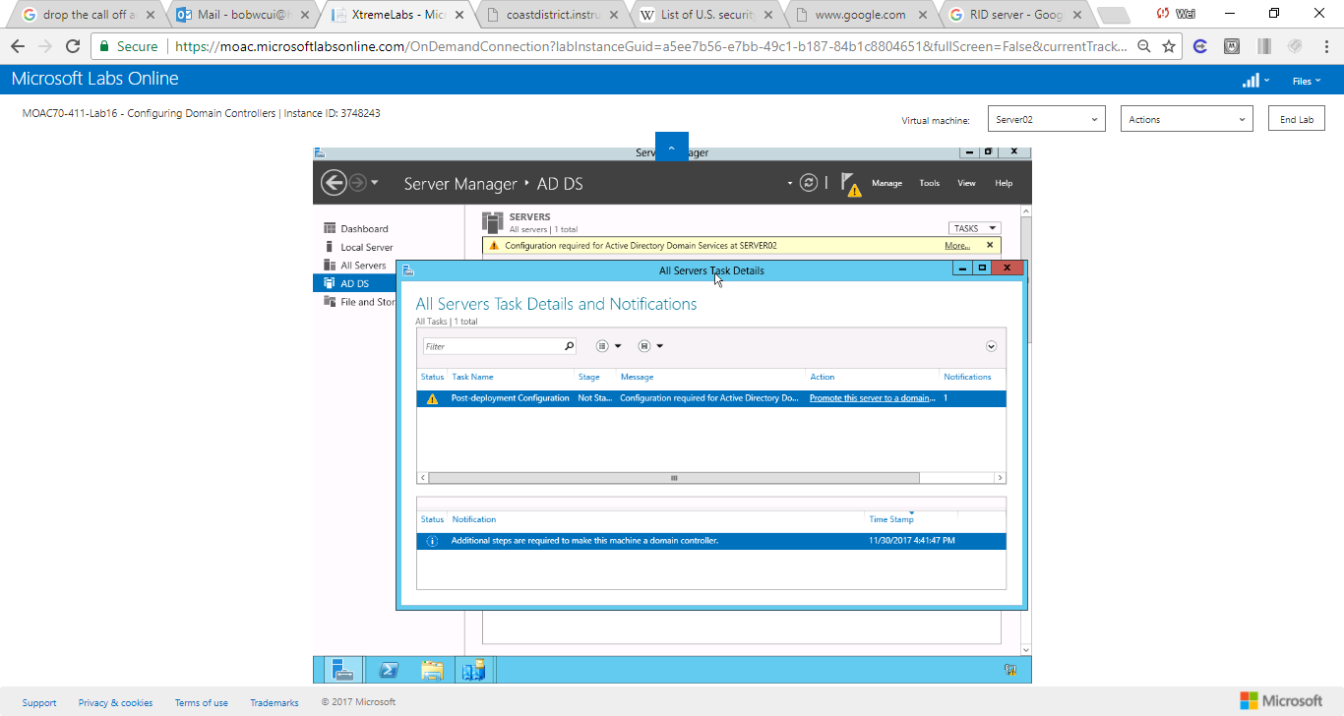

Figure 1 screenshot shows All Server Task Details though AD DS.-> More in the yellow bar

**12.** When the All Servers Task Details window open, click *Promote this server to a domain controller*. The Active Directory Domain Services Configuration Wizard starts.

**13.** On the Deployment Configuration page, confirm that *Add a domain controller to an existing domain*isalready selected, click Next.

**14.** On the Domain Controllers Options page, selectRead only domain controller (RODC), as shown in Figure 16-3. Select the correct site name (Default-First-Site-Name, in this case). In the Password and Confirm Password text boxes, type **Password01**. Click Next.

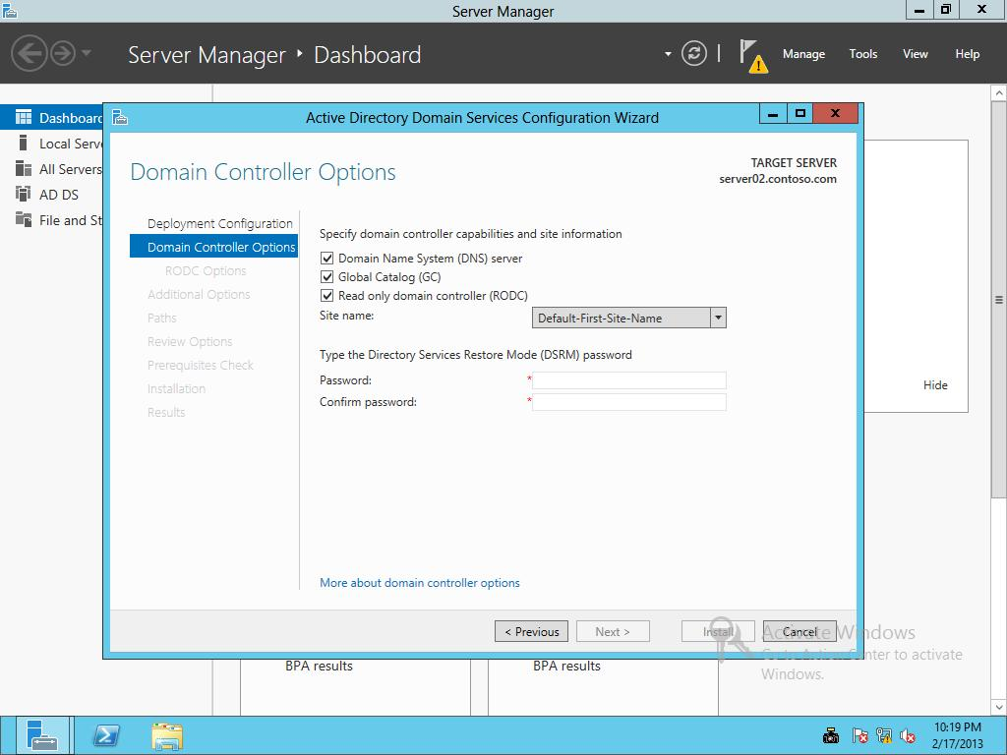

Figure 16-3

Promoting a server to a read-only domain controller

**15.** On the RODC Options page (as shown in Figure 16-4), under Delegated administrator account click Select. In the text box, type **App1Service** and click OK. Click Next.

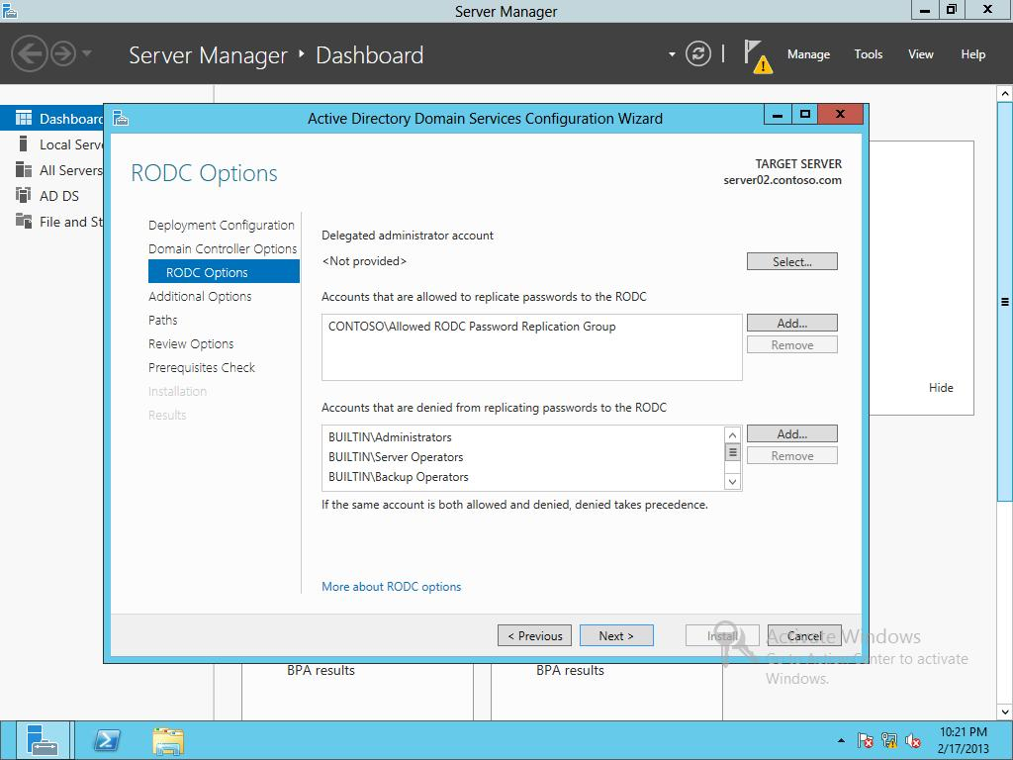

Figure 16-4

Configuring RODC options

**16.** On the Additional Options page, click Next.

**17.** On the Paths page, click Next.

**18.** On the Review Options page, click Next.

**19.** On the Prerequisites Check page, click Install.

**20.** When the installation is complete, Windows automatically restarts the domain controller.

**21.** On RWDC01, using Server Manager, Tools, open Active Diretory Users and Computers.

**22.** Navigate to the Domain Controllers OU. Wait for Server02 to reboot. Then right-click Server02 and click Properties. The Properties dialog box opens.

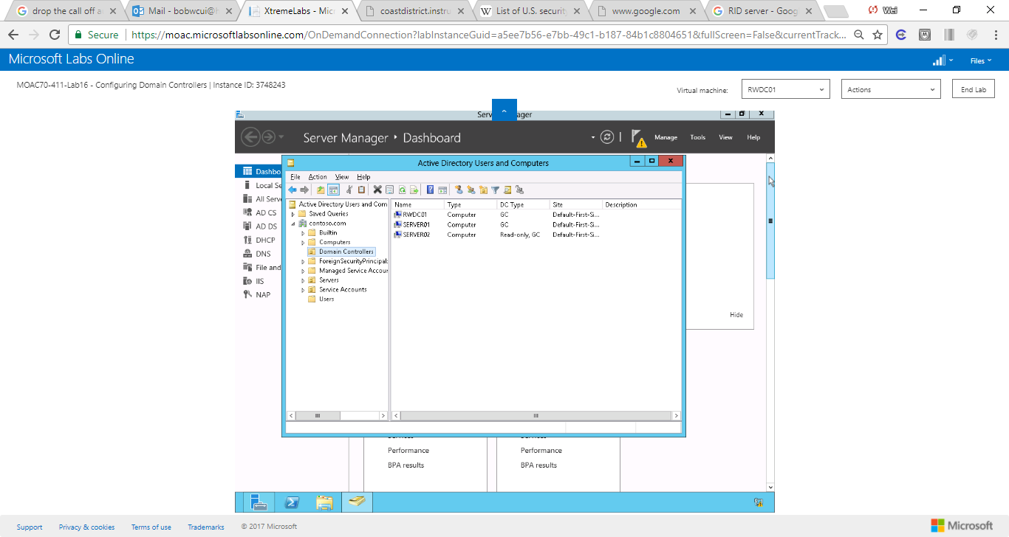

Figure 2 Screenshot shows Server02 displays in domain controller OU.

**23.** Click the Password Replication Policy tab to view the current password replication policies.

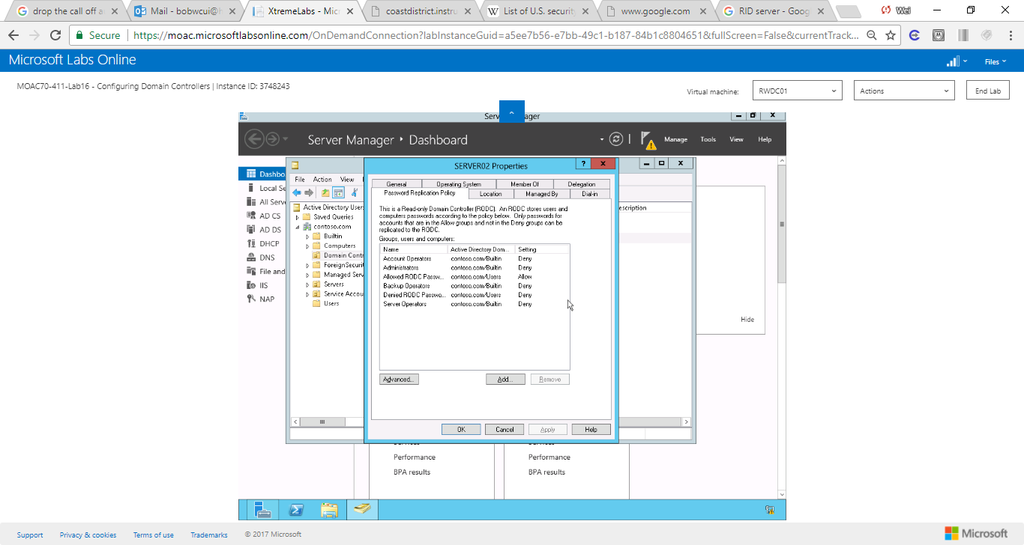

Figure 3 Screenshot shows the properties in Password Replication Policy tab

**24.** Click OK

End of exercise.

**Lab Summary**

In this exercise, I created and deployed a read-only domain controller (RODC). The database on an RODC is read only. Applications can only read data from the directory when they target an RODC. An RODC only replacates data fro a writeable domain controller, it never replicates data to another domain controller. RODCs have a complete copy of the database with the exception of credentials and credential-like attributes.